LTE-HeNB项目

LTE-HeNB联调
PicoChip物理层平台
说明文档

拟制：杨喜宁
时间：2011.10.25

中国科学院计算技术研究所
先进无线技术联合研究中心
LTE-HeNB项目组

修改记录
文件编号 | 版本号 | 拟制人/  修改人 | 拟制/修改日期 | 更改理由 | 主要更改内容  （写要点即可）
 | 0.1 | 杨喜宁 | 2011-10-25 | 建立
注1：每次更改归档文件（指归档到组内及研究室的文件）时，需填写此表。
注2：文件第一次归档时，“更改理由”、“主要更改内容”栏写“无”。
修改列表：
无。


本文档的程序或内容受版权法的保护，未经中科院计算所的书面许可，不得擅自泄漏、拷贝或复制本文档资料的全部或部分。

引言

编写目的

背景

参考资料

硬件平台介绍

PC9608
PC960x is the Picochip platform for Local Area and Home eNB development. It is a software upgradeable solution, fully configurable to support either LTE FDD or TDD operations. PC9609 is the platform configured for FDD and PC9608 is the TDD version.

PC9608 main components are:
• 2 x PC7608 Picochip Baseband Card ( hosting 2xPC203) for running the Picochip LTE Physical Layer (PC8608)
• Kontron AM4204 AMC card (hosting a Cavium Octeon Plus CN5650, 12 cores @600MHz ) for running the LTE L2/L3 software
• PC7652 (Picochip Radio Card)radio modules for functional test
• Kontron Chassis (Kontron OM6040-250W) supporting PCIe/GbE/SERDES/SRIO communication interfaces

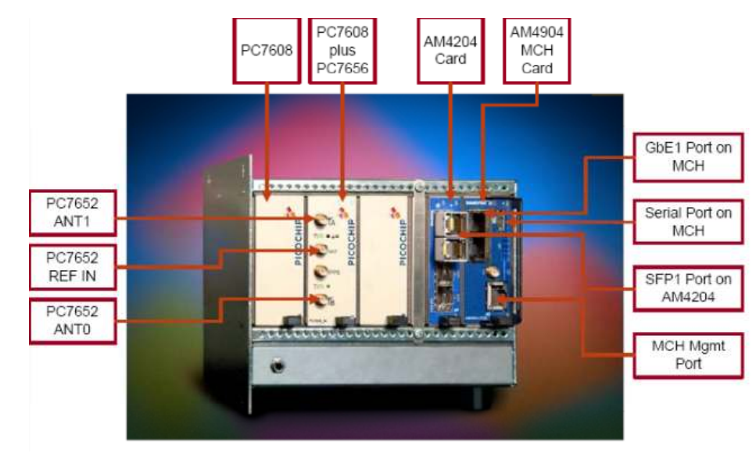

Test environment setup
The configuration setup requires two laptops:
• eNB PC controlling the PC960x
•UE PC controlling the TM500 or any other LTE commercial UE software suite
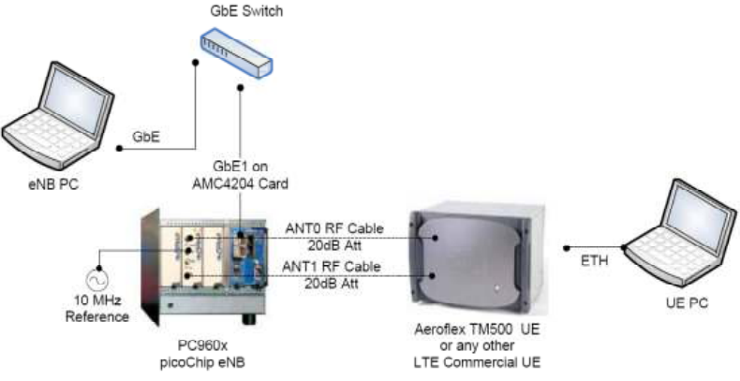

Access to the Cavium Card (AM4204)
Command line interface access
To access the command line interface to the Linux / Bootloader running on Cavium card from the Host Machine, connect to GbE1 port on to MCH card.
- Configure IP Address of GbE MAC on AM4204 via GbE1
- IPMI Tool
IPMI tool provides access to Cavium card serial port via SOL (Serial Over LAN)
- SSH
- Telnet

Other
- Boot variable configuration
- LTE eNB Software installation
- Install pc8608_cl1emu_<binary/source>_package.tgz to PC960x hardware
- Install Cavium OCTEON SDK & Linux RPM (baseline)
It is build environment of CL1 EMU build source code
- Build instructions and execution
CL1 emulation, (CL1 EMU, Convergence Layer1 Emulator), is an application used to drive the L1 software on PC7608.

L1 API

L1 API Interactions
L1 API是 LTE MAC层和 PHY 物理层的处理接口，主要负责处理MAC层的消息，控制并调度 PHY 物理层链路处理。
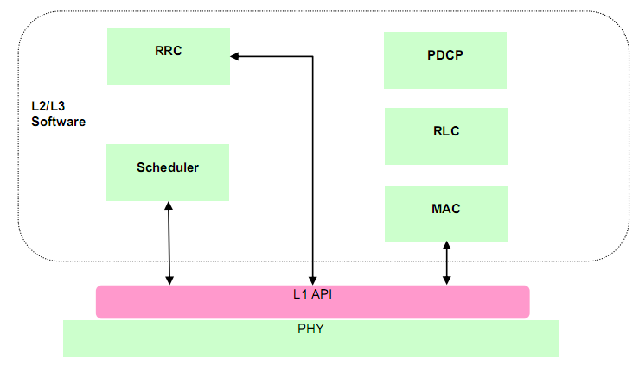

L1 API Procedures
- configuration procedures
Configuration procedures handle the management of the PHY layer and are expected to occur infrequently.
- subframe procedures.
Subframe procedures determine the structure of each 1ms subframe and operate with a 1ms periodicity.

Configuration Procedures
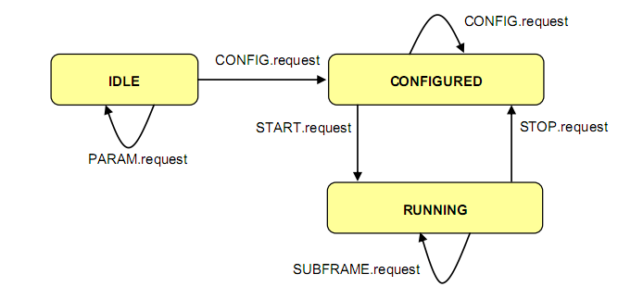

Subframe Procedures
The subframe procedures have two purposes. Firstly, they are used to control the DL and UL frame structures. Secondly, they are used to transfer the subframe data between the L2/L3 software and PHY.
The subframe procedures supported by the L1 API are:
- Transmission of a 1ms SUBFRAME signal
- Synchronization of SFN/SF between the L2/L3 software and PHY
- Transmission of the BCH transport channel
- Transmission of the PCH transport channel
- Transmission of the DL-SCH transport channel and reception of ACK/NACK response
- Transmission of the MCH transport channel
- Reception of the RACH transport channel
- Reception of the UL-SCH transport channel and transmission of ACK/NACK response
- Reception of the sounding reference signal
- Reception of CQI and RI reporting
- Reception of scheduling request information

测试系统架构

用户面上下行数据测试

主线程
主线程中主要功能是初始化core data， 创建ue实体、配置SRB及各层参数，并创建其他线程，具体如下：
- core date初始化，SRB配置
- simphy 启动定时器
- lowmac 创建三个消息队列、帧号初始化、缓存初始化、创建lowmac_ctrl线程
- lowmac_ctrl线程
接收：从g_to_lowmac_rx_msgq消息队列接收物理层数据，并将数据发送到g_to_mac_rx_msgq
发送： 将g_lowmac_tx_buffer中数据发送到simphy
- init_pdu_rx
创建rx_mac_msg线程（从消息队列g_to_mac_rx_msgq接受消息调用mac解帧函数-> RLC PDU处理 ->PDCP数据包处理-> ip_receive ->verify_sdu
- init_henb_send
创建start_henb_send线程，获取g_mac_tx_sem信号量，进行上下行调度处理（包括从RLC缓存获取RLC PDU）并将数据发送到lowmac缓存g_lowmac_tx_buffer
- init_ue_config
创建UE实体，创建RB、配置各层参数（PDCP、RLC
- rx_task_func
创建接收线程，从物理层socket接收数据并发送到g_to_lowmac_rx_msgq.
- construct_data_func
创建构包线程，构造 PDCP SDU，经PDCP层相关处理后，调用RLC接口生成RLC PDU存到RLC缓存

功能框图

